Origins: Where Are the Aliens? Overhead

Exploring Spectra

Both of the following show the visible-light absorption spectrum for our sun. Notice that the second graph reveals more information—the amount of light absorbed is included.

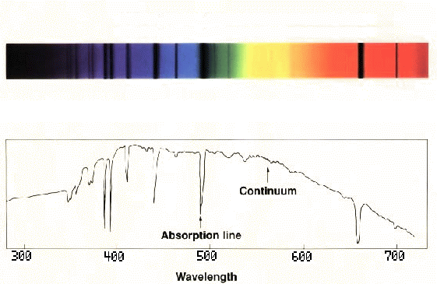The Sun’s Spectrum
Hydrogen
Absorption Lines
Hydrogen
Absorption Lines
Continuum
Absorption Line
Wavelength in nanometers

ultraviolet wavelengths
Intensity
visible wavelengths
infrared wavelengths

